Last Updated: 5/19/2016
Madison County School’s
11th Annual North Alabama Technology Conference
Sponsorship Opportunities
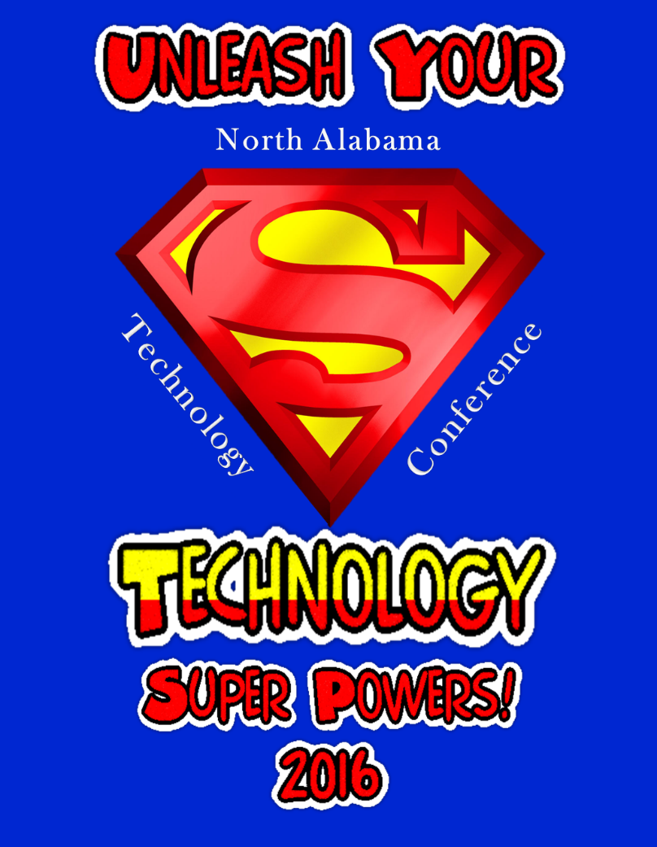
http://natc2016.weebly.com/
June 21 & 22, 2016

Meridianville Middle School 12975 Hwy 231/431 North Hazel Green, AL 35750
The 11th Annual North Alabama Technology Conference, sponsored by the Madison County School System, is open to all school systems in North Alabama, but particularly to the 12 school systems in Madison, Marshall, Jackson, and Dekalb (all in the Regional Inservice Center for UAH/Alabama A&M) and also the school systems in the regions to the west including but not limited to Limestone and Morgan counties. We are planning for approximately 500 educators to attend the conference.
Interested in becoming a participating sponsor? If so, we are currently enrolling sponsors for the 2016 conference.

For information on our sponsorship levels and their benefits, see below:
SILVER | BRONZE | GENERAL
$500 | $300 | Any $ Amount
For you:
Booth (6 foot table) | Booth (6 foot table) | No booth
Electrical outlet/wireless internet | Electrical outlet/wireless internet | N/A
Lunch provided for up to five people per booth | Lunch provided for 2 people per booth | N/A
½ page color ad in program | 1/4 page color ad in program | Name in list of donors in program
Company name and link on website | Company name and link on website | Name in list of donors on website
May present at your booth in the Exhibit Hall (located in gym right off the Lobby) | May present at your booth in the Exhibit Hall (located in gym right off the Lobby) | No presentations
May speak at lunch (one day) for 2-3 minutes (slide with your logo shown at lunch) & signage with your company name displayed in lobby/cafeteria area |  | N/A
From you:
Donate door prize (approx.$25) | Donate door prize (approx.$25) | Donate door prize(approx.$25)
Donate items for goodie bags such as lanyards, notepads, pens, stress balls, cups, or anything that might fit our theme. | Donate items for goodie bags such as lanyards, notepads, pens, stress balls, cups, or anything that might fit our theme. | Donate items for goodie bags such as lanyards, notepads, pens, stress balls, cups, or anything that might fit our theme.
Supply Company flyer or brochure for goodie bags if desired. | Supply Company flyer or brochure for goodie bags if desired. | Supply Company flyer or brochure for goodie bags if desired.
*Must receive items for the Goodie bags by June 9th.
Door prizes can be sent early (to the address below) or bring with you to Conference.
You will be provided a complimentary list of attendees before the conference upon request.
Exhibit hours are: June 21--9:30 – 3:00 and June 22--9:30 – 12:15
Setup on June 20- 2:00-4:00 or June 21 before 9:30 a.m.
Booth equipment can be sent to Meridianville Middle School in advance if desired.
Please complete the attached form and send it along with check to:
LaQuita Nance, Bookkeeper, Madison County Career Tech Center
1275 Jordan Road, Huntsville, AL 35811
Or Fax form to: 256-851-9790 (and send check separately)
Questions regarding sponsorship can be directed to Vickey Sullivan. (vsullivan@madison.k12.al.us or 256-852-2557, ext. 61284)
Note: We are also looking for lunch, t-shirt and lanyard sponsors. Inquire with Vickey if you are interested.

Sponsorship for 2016 North Alabama Technology Conference
*Fill in Form Available on website---- natc2016.weebly.com
Company ________________________________________________________________________
Company Address _________________________________________________________________
City, State, Zip ____________________________________________________________________
Contact Person: Phone: Email address:
Person(s) Attending: Phone: Email address (es):
I would like to be a sponsor:
_____ SILVER Sponsor ($500) (you provide approx. $25 door prize, items for goodie bags such as lanyards, notepads, pens, stress balls, cups, or conference theme-related items, flyer/brochure if desired, may present at your booth, may present at lunch for 2-3 minutes on one day) *Please provide a colored jpeg image for ½ page ad for program (see details below)
_____ BRONZE Sponsor ($300) (you provide approx. $25 door prize, items for goodie bags such as lanyards, notepads, pens, stress balls, cups, or conference theme-related items, may provide a flyer/brochure for bags, if desired, may present at your booth)
*Please provide a colored jpeg image for 1/4 page ad for program (see details below)
_____ GENERAL Sponsor (any $ amount) (you provide approx. $25 door prize, items for goodie bags such as lanyards, notepads, pens, stress balls, cups, or conference theme-related items, and a flyer/brochure if desired)
Please make checks payable to: Madison County Career Tech Center (MCCTC) and forward to:
LaQuita Nance, Bookkeeper, Madison County Career Tech Center
1275 Jordan Road, Huntsville, AL 35811
Or Fax form to: 256-851-9790 (and send check separately)
Image requirements:
½ page ad- 4.5 x 6 inches (approx. 640 x 480 pixels) jpeg
¼ page ad- 3 x 4 inches (approx. 350 x 400 pixels) jpeg
*All ads will be in color.
Other Comments: ______________________________________________________________________________________________________________________________________________________________________________________________________________________________________________________________________________________________________
Signature ___________________________________ Date: ___________________________________
Questions?
Contact: Debbe Brooks, dbrooks@madison.k12.al.us 256-852-2557 Ext. 61281
Or Vickey Sullivan, vsullivan@madison.k12.al.us 256-852-2557 Ext. 61284

